CONCRETE MIXER HK4.0
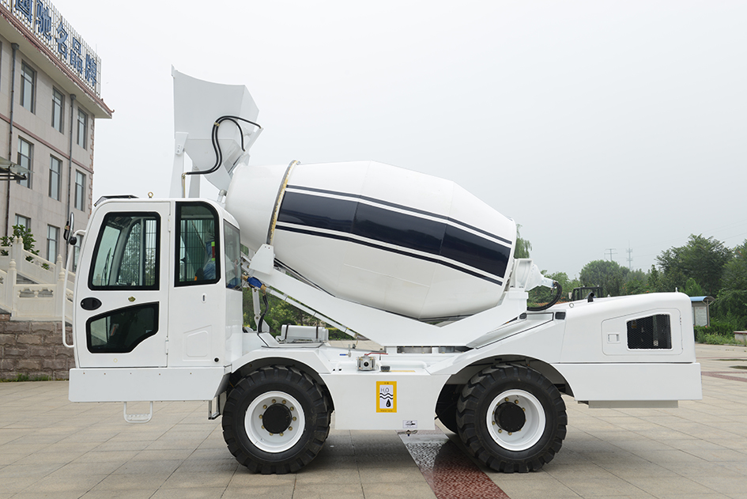
Specification：
型号规格 MODEL NO | 型号：HK4.0 Model: HK4.0
型式性能 TYPE | 一体底盘移动式、自装卸料、搅拌、运送  Integral frame chassis movable, self loading, mixing, transporting
功能  FUNCTION | 混凝土、沙浆、化肥复合、饲料等散状物料的湿式（或干式）拌合并能将物料自行卸到目的地 concrete, sand, fertilizer compound, wet or dry feed materias mixing and discharging
生产功能：PRODUCTIVITY | 批次≤15分钟，每小时4批（16方）  BATCH≤15MINS, 4BATCHS/HOUR
驱动 | 4 x 4
转向 steering | 后轮转向 Front steering
发动机：  ENGINE | 云内 4缸2200转/分钟，92KW.中冷增压 YUNNEI ENGINE: FOUR-CYLINDER 2200RPM,92KW
行走速度：SPEED | 高速36.5公里/时 低速6.5公里/时  HIGH SPEED: 36.5KM/H; LOW SPEE:6.5KM/H
档位  Gear number | 前进挡3个，倒挡3个  Three forwards, three backwards
油耗  Fuel consumption | 怠速状态2L-3L,工作状态6L-8L.  Idle state 2L-3L, working state 6L-8L.
轮胎：TIRE | 16/70－20（钢丝轮胎） (Steel wire tyre)
搅拌罐：DRUM | 几何容积5.5立方米，最佳搅拌3.5-4立方米  Geometric volume 5.5 cubic meters, the best stirring 3.5-4 cubic meters
罐内螺旋叶片  Spiral blade in tank | 双螺旋线搅拌，配导流螺旋，使搅拌物料更均匀。左旋进料右旋出料  Double helix mixing, with the guide screw, so that the mixing material more uniform.Turn the feed left, turn the discharge right
搅拌罐270度卸料  mixing tank 270°discharges | 罐体水平旋转达到270度。车辆周围卸料无死角The tank rotates horizontally to 270 degrees.There is no dead Angle for discharging around the vehicle
溜料槽：TIPPING CHUTE | 配2节副溜料槽可拆卸，为增加卸料长度  Equipped with 2 chute for detachable to increase discharging length
铲斗：SHOVEL | 容量0.55立方 shovel capacity: 0.55³
铲斗放料开关  Bucket discharge switch | 液压闸门，电控  Hydraulic gate, electric control
操纵杆：OPERATION HANDLE | 电控按钮四向先导手柄  ELECTRIC CONTROL BUTTON FOUR-WAY GUIDE HANDLE
行走液压：  MOVING HYDRAULIC | 泵（DENGHONG）PUMP:DENGHONG
行走液压：  MOVING HYDRAULIC | 变矩器（HANK）  Torque converter（HANK）
工作液压  Work hydraulic | 泵/阀（DENGHONG）  PUMP/valve: DENGHONG
搅拌系统  Mixing system | 减速机（HANK）  SPEED REDUCER:（HANK）
搅拌系统  Mixing system | 搅拌马达(镇江大力)  Mixing motor（ZHENJIANG DALI）
驱动车桥Drive axle | 柳峰 LIUFENG
供水系统：  WATER SUPPLY | 上水：液压驱动自吸式水泵。  HYDRAULIC DRIVING SELF-PRIMIING PUMPS.
高压洗车  HIGH-PRESSURE WATER PUMP WASH | 电子高压水泵冲洗  HIGH-PRESSURE WATER PUMP WASH
称重系统  Weighing system | 电子称重系统（语言可选）  Electronic weighing system (language optional）
电压：VOLTAGE | 配电池两块24V,100A。  Battery 24V-100A 2 pieces
液压油箱：HYDRAULIC OIL BOX | 容量180升夏季68号液压油，冬季用46号液压油，严寒地区配35号液压油。配备液位计。  TANKAGE180L, SUMMER:NO68 HYDRAULIC OIL, WINTER:NO46 HYDRAULIC OIL, VERY COLD ZONE: NO35 HYDRAULIC OIL
水箱容积  Water tank capacity | 520L
柴油箱容积  Diesel tank capacity | 180L
质量  whole weight | 整备质量 7600KG  COMPLETE VEHICLE KERB MASS 7600kg
驾驶室 CAB | 防落物驾驶室 Prevent falling objects cab
驾驶室 CAB | 可调方向盘 Adjustable steering wheel
驾驶室 CAB | 可调式座椅 Adjustable seat
驾驶室 CAB | 安全带 Seat belts
驾驶室 CAB | 灭火器 Fire extinguisher
驾驶室 CAB | 倒车影像 Astern image
车顶警灯ALARM LAMP | 标配 STANDARD CONFIGURATION
收音机RADIO | 标配 STANDARD CONFIGURATION
驾驶室空调 A/C | 可选optional
逃生锤ESCAPE HAMMER | 标配STANDARD CONFIGURATION
倒车声音提示  Astern sound prompt | 标配STANDARD CONFIGURATION
行走控制方式  Walking control mode | 标配：机械 | 可选：电控
行走控制方式  Walking control mode | STANDARD CONFIGURATION：mechanical | Optional：Electric control

Overall size drawing：
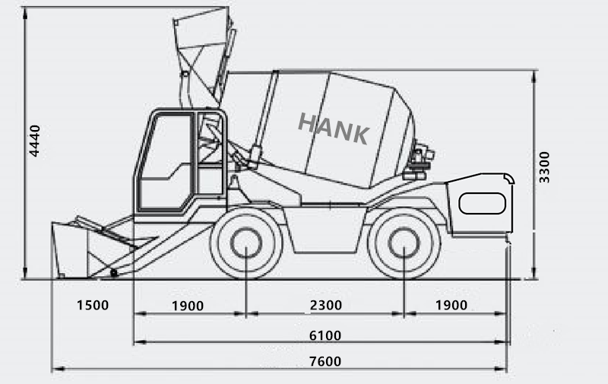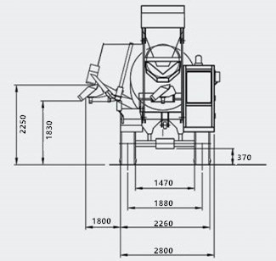

Optional:
1：Engine brand.
2: A/C
3: Electronic weighing system
4: High pressure car washing machine
5: Electric control walking system
6: Mixing tank 270°discharges
7: Centralized lubrication system
8: Cement storage hopper
Free spare parts
No. | Name | Quantity
1 | 发动机机油滤芯 | 1套
2 | 发动机空气滤芯 | 1套
3 | 发动机柴油滤芯 | 1套
4 | 15Pressure regulating valve  15 调压阀 | 1个
5 | 20 Pressure regulating valve  20 调压阀 | 1个
6 | Flameout controller  熄火控制器 | 1个
7 | Pump coupling  水泵联轴器 | 1个
8 | Pump coupling pad  水泵联轴器垫 | 1个
9 | Gasket  密封垫 | 1代
10 | Insurance piece  保险片 | 1盒
11 | Grease nipple  黄油嘴 | 10个
12 | 工具箱Toolbox | 1套

